Kevin Chen

12/15/18

Course One: Aerial Robotics

**Introduction**

Unmanned Aerial Vehicles

* UAV is a very large industry.
* Leading applications: agriculture, photography, infrastructure inspection, construction, border patrols, film production
* Other terms for UAV’s: aerial robots, remotely piloted vehicles (military), drones
* Aerial Robotics is evolving. There is a lot of concern for regulation (safety, privacy, security)
* This course focuses on micro aerial vehicles.
* Types of micro air vehicles: fixed wing (cannot hover), flapping wing (can hover, but fluid mechanics is complicated), rotor crafts (helicopters, ducted fan, co-axial)
* The vehicle used by this course is the quadrotor (four rotors)

Quadrotors

* Simple geometry: four independently controlled rotors on a rigid frame.
* Direction the motors spin:

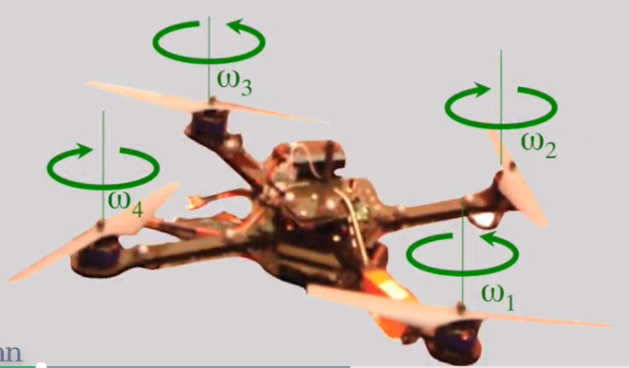

* Roll and Pitch movement: left motor spins faster than right, causing it to pitch/roll to the right.
* How to get the robot to steer (or yaw) -- Translation: pitch the robot so that the thrust factor points in the horizontal direction. As you get close to the destination you want to stop the vehicle by pitching it in the opposite direction to slow it down. Finally, pitch it back in equilibrium.
* The robot has six degrees of freedom: translate in all three directions and rotate along all three axes.

Key Components of Autonomous Flight

* Autonomous flight requires these key components:
  + State estimation (both state and velocity – both translational and rotational velocity)
  + Control (command motors for desired actions to navigate to desired state)
  + Mapping (its environment)
  + Planning (compute a trajectory)

State Estimation

* Obtain reliable estimates of position and velocity
* In lab setting, you can have cameras identifying exact position of reflectors at a fast rate.
* In real environment, GPS and other kinds of communications are used
* GPS can be unreliable, esp. next to tall buildings and indoors.
* How to navigate without GPS or external motion capture cameras?
  + Vehicle is equipped with sensors like cameras (including depth cameras), laser sensors.
* Simultaneous Localization and Mapping (SLAM): try to estimate your own position and the positions of certain features in the environment.
* As an alternative to external motion cameras, you can have a camera on the robot with beacons (e.g. AprilTags) lying on the carpet.

Applications

* Agriculture: precision farming (obtain info about the plants), get models of plants, identify plants that need special attention, getting estimates for yield, determining which plants to water and when.
* Construction: 3-D maps of buildings, owner can monitor progress, plan for resource allocation
* Archaeology: 3D information about historical sites/landscapes/buildings
* Photography: breathtaking pictures, obtaining vistas that normally can’t be obtained
* First responders: rush to emergency sites before human responders

What is MATLAB Aerial Robotics

* Packages to perform mathematical tasks with simple commands.
* Focuses on matrix operations
* (Omitted Matlab installation instructions)

Introduction to the Matlab Environment

* Variables
  + Assignment operator. Example: x = 1.
  + Variable names start with a letter. Only contain letters, numbers, and underscores. Case-sensitive.
  + Ending a statement with a semicolon prevents the output from being displayed.
  + If you don’t assign the output of an expression to a variable, it is automatically assigned to a variable named “ans”.
* Creating Vectors
  + Example: x = [-2, -1, 0, 1, 2] creates a row vector
  + Example: x = [-2; -1; 0; 1; 2] creates a column vector
  + Plot two row vectors, x and y, with the command “plot(x, y)”
* Using the : operator
  + The colon operator lets you create uniformly based vectors.
  + Format: x = *startValue*:*spacing*:*endValue* creates a row vector beginning with *startValue*, incrementing by *spacing* for subsequent values up and until *endValue*.
  + Example: x = -2:0.1:2. This creates [-2, -1.9, -1.8, …, 1.9, 2]
  + Example: x = -2:0.15:2. This creates [-2, -1.85, …, 1.75, 1.9]
  + By default, the spacing is 1. For example: x = -2:2. This creates [-2, -1, 0, 1, 2]
  + Create a column vector by adding parenthesis (for order of operators) followed by an apostrophe (the transpose operator). Example: x = (-2:2)’
* Functions
  + Syntax for calling a function: [*out1*, *out2*, …, *outm*] = *fun*(*in1*, *in2*, …, *inn*) where function “fun” has “m” out parameters and “n” in parameters.
  + Example: [a, I] = min([-1, 1, 0, 2]). “a” is the min value, “I” is the index of the min value.
* MATLAB as a Calculator